Name: Zainab Azeem

Roll no: 21P-8025

Program: BCS

Ques no 1 Code

a=[1,3,5] #slice (start:stop:step)

b=[2,4,6]

c=a+b

print(c)

c.append(7)

c.append(8)

c.append(9)

print(c)

print("first 3 elements in c;",c[0:3])

print("last element of b:",b[-1])

print('length of a:',len(a))

size=len(c)

sum=0

for i in range(size):

sum=sum+c[i]

avg=sum/size

print("average is",avg)

minvalue=c[0]

for i in c:

if i<minvalue:

minvalue=i

print("minimum value:",minvalue)

c.insert(4,42)

print(c)

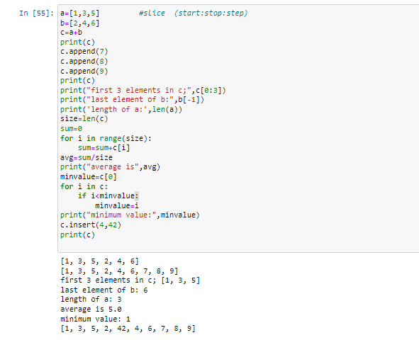

Question no 2:

def common_number():

x=[7,2,3,4,5]

y=[6,6,7,8,9]

for i in x:

for j in y:

if i==j:

return True

else:

return False

common_number()

